WOULD YOU LIKE TO RECEIVE UPDATES FROM THE MIRAMAR JET FUEL FOOD PANTRY?
We will be sending out reminders about events like the Really, REALLY, Free Farmers Market, information about new items at the pantry, opportunity drawings, coupons and more!
To receive important updates:
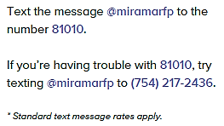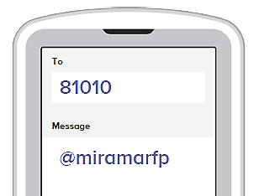

- After you send the text to join, you will receive a response that asks you to reply with your first and last name.
- You will receive a text back that indicates you have joined Miramar College Emergency Food Pantry. Please be aware that this is a one way service only. You will receive messages from Miramar College Emergency Food Pantry, but you will not be able to reply back.
- There will be a link to get the Remind app. This is optional.
  - If you click on it, you will be sent to the app store where you can install the app for free.
  - Once installed, open the app. The first time you open the app, you will be asked to enter your email address.
  - Next you will create a password.
  - When asked, select I AM A STUDENT (not I am a parent or teacher).
  - It will ask if you signed up via text, click yes. You will then link your phone number to import your classes (your “class” is Miramar College Emergency Food Pantry). Click link my phone.
  - It will ask you to enter your name, this is how it will appear to the Coordinator of the Food Pantry
- To receive updates via email only, go to rmd.at/miramarfp to sign up for email notifications
- You can opt out of messages at any time by replying, unsubscribe @mirmarfp

