San Diego Miramar College
Technology Committee
February 24, 2009
Room I-105

Present: Susan Schwarz, Tom Davenport, Janice Hecksel, Todd Williams, Kurt Hill, Rechelle Mojica, Mike Charles, Namphol Sinkaset, Temmy Najimy, Wahid Hamidy, Glenn Magpuri, Bethany Morgan (ASC Rep.)

The meeting was called to order at 2:03 p.m.

- Welcome
S. Schwarz welcomed everyone to the meeting and introduced the newest member to the committee, Bethany Morgan, ASC Representative. Committee members introduced themselves and briefly described their role at Miramar College.
- Approval of November 13, 2008 minutes
M. Charles moved to approve November 13, 2008 minutes and it was seconded by T. Davenport. Approved by consensus.
- Approval of Agenda
J. Hecksel requested to add “C. IELM Request for Funding” under V. New Business. With the following request, M. Charles moved to approve agenda and it was seconded by R. Mojica. Approved by consensus.
- Old Business
  - Update Technology Plan Draft
Technology Plan 2006-2009 is available at http://www.sdmiramar.edu/cmte/cmteTemplate.asp?cmte=TECH
Committee needs to update Technology Plan for 2009-2013 and address the following in Technology Plan:
-Software
-Distance Education
-New buildings
-FF&E for new buildings
-Licenses for the campus
-Digital signage
-Address budget for licenses (currently using IELM funds; IELM funds cannot be use for renewal licenses)
-Faculty computers (should faculty have an option to choose either a desktop or a laptop. Committee will look into security for laptop).
-Wireless Access (Leave of Legacy Plaza, Internet Café, etc.)
Note: M. Charles and K. Hill will work on updating Technology Plan for 2010-2013. M. Charles recommended committee to address “New Buildings” in the plan. J. Hecksel suggested for Deans to meet with her and K. Hill to discuss computers for FF&E for new buildings. R. Mojica would like to be involved in FF&E furniture process for new buildings to make sure it is ADA compliance.
  - Update Wireless Access
K. Hill reported currently there are wireless accesses for the Library, The PLACe, S-500 Classrooms/Labs, and PDC (T-100). Special thanks to SunGard, Kent Keyser, and Glenn Bowers for assisting the campus in obtaining wireless access.
Please see below for wireless access handouts for the PDC (T-100).
How to Connect to Miramar College T100 Wireless Network

To connect to the wireless network in the Miramar College Library, open the computer’s Wireless Network Connection. Highlight the PDC Wireless network. Click Connect.

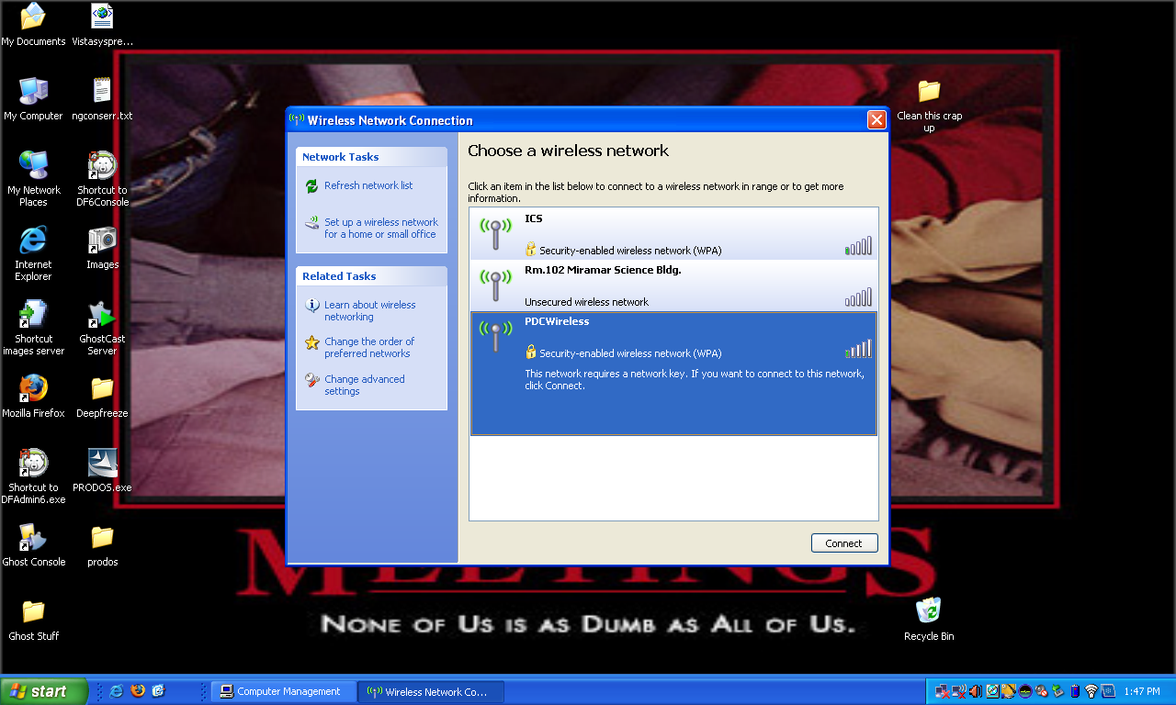

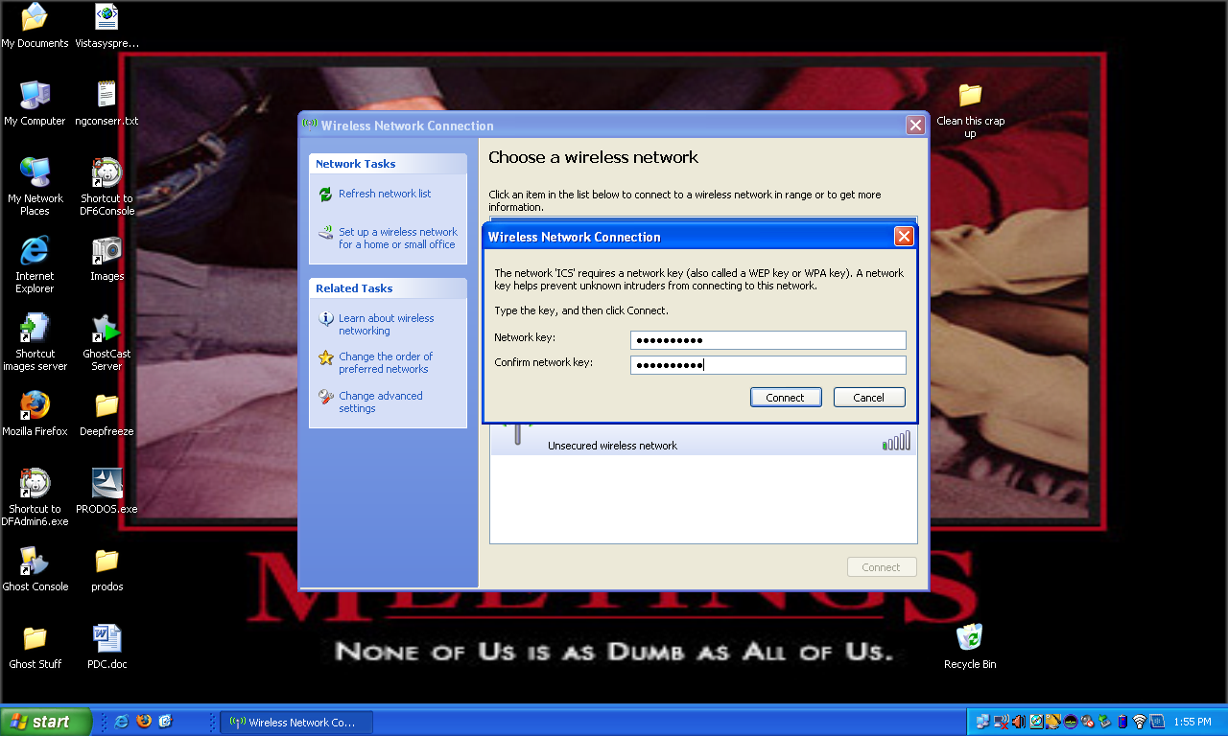

Enter the Network key: Miramar@PDC Retype to confirm. Click Connect.
(The Connect button now turns to Disconnect.)
SUPPORT: There is no after-hours (after 4:30PM) or weekend support. For questions or to report problems, please email miramar.ics@sdccd.edu, call Instructional Computing Support at ext. 7387 or Kurt Hill at ext. 7744.

Miramar College T100 Wireless Information

- The T100 Building has wireless for faculty/staff use.
- This connection is only for internet accessible areas such as the web servers. It will not get you to any of the SDCCD internal programs such as Outlook etc.
- The College cannot guarantee that any given device will connect. If your computer cannot connect, we suggest you use one of the computer stations provided in the PDC.
- You must navigate wireless connectivity without staff assistance.
- Wall Ethernet ports are not available for Internet connectivity.
- Printing is not available from the wireless network.
- The College does not provide virus or spyware scanning for this Internet connection. It is very important that you have up-to-date anti-virus software, anti-spyware software, and a firewall installed on your computer. In addition, your computer’s operating system and Internet browser should be current with updates.

Security and Privacy Precautions

Use common sense when using any public wireless network. Take precautions when doing anything sensitive on a wireless network when you're not sure about who's sharing it with you. Avoid sending personal information, business information, userIDs, or passwords. Keep the use of password protected activity like e-mail, eBay, and FaceBook, etc., to a minimum. Don't make credit card purchases.

Liability Disclaimer

It is the responsibility of each user to protect his or her computer against any potential abuse such as viruses, malware, and breach of privacy. SDCCD \ Miramar College assumes no responsibility for any direct or indirect damages arising from the use of its wireless connection to Internet services.

  - Web Storage
K. Hill reported a faculty requested for more web storage. He educated the faculty on how to maintain files. Example, instead of uploading full video files, faculty need to compress the files, then uploads.
  - Additional Email Space
S. Schwarz reported district is not giving any additional bandwidth for email space. J. Hecksel suggested for users to archive and clear out their emails by deleting big files and emptying delete box.
- New Business
  - Committee Chair & Co-Chair for 2009/2010
S. Schwarz brought forward for nomination for electing a Co-Chair for 2009-2010.
  - Governance Page Review & Change Recommendation
Committee are asked to give recommendations on Technology Committee Governance Handbook pg. 23
Technology Committee

Co-Chairs:
Faculty – Recommendation elected by Committee - Two Year Term, and Dean of Library and Technology

Committee Membership:
Administrators (7) Classified (3) Faculty (7) Students (1)
The Committee shall include the Instructional School Deans and Vice President of Instruction, Vice President of Student Services, Dean of SDCCD On-line, the Audio/Visual Technician, the Microcomputer Specialist Supervisor, the Contracted Campus Technology Specialist, seven faculty representatives, one from each Instructional School, one Librarian, one member of student services, one member of the Academic Senate Executive Committee, and one Student appointed by the ASC. Since this committee is composed of a large group who may not all be able to participate at every meeting the minimum Quorum is five (5) members. This shall include at least two Administrators and two Faculty. At all times, the entire membership shall be subject to all committee agendas, minutes and correspondence.

Committee Goals:
The mission of the Technology Committee is to provide organization, recommendations, direction, and standards for campus technology. The structure of this Committee will rely upon the operational role of the Deans and Vice Presidents to orchestrate the continued development of the on-going Technology Plan, to advocate and support Instruction and Services utilizing technology, and to coordinate funding resources to maximize technology implementation campus wide. All the above listed members are voting members but the Committee will rely heavily upon the Administrative capacity to organize and promote process much like the College relies upon them to orchestrate the publication of the College Course Catalog and Schedule.

The Committee will:
Develop and update 3-year Instructional Technology Plan
Establish technology standards and procedures for the College
Determine technology needs and priorities to support all instruction, services, and administration
Provide technology direction and oversight for the Website Sub-Committee
Maintain an inventory including status, warrantee, and condition of all campus technology and supporting infrastructure to include all non-program specific campus technology.
Provide technology expenditure recommendations to the Planning and Budget Committee.
Provide direction and guidelines for Audio/Visual Department to ensure adequate Audio/Visual support.
Coordinate technology training efforts with the Staff Development Committee.
Coordinate and assist with technology planning efforts in Strategic, School and Department planning.
Provide technology data, reports and assistance for Accreditation.

Committee Procedures and Calendar:
The Committee Chairs are the advocates for the Committee and will carry forward Committee recommendations to the following committees as appropriate:
All Standing Committees for review and input as needed
Planning and Budget Committee for technology expenditure recommendations, and College Executive Committee through normal Senate/Council channels.
The Committee will review and revise annually the 3-year Technology plan by April 30. The plan will include the following components:
What technologies will best meet campus and program needs;
Priorities for implementing these technologies into the classrooms and work places, and; The status of existing campus technologies;
The Committee will establish short term task forces to accomplish much of its work, as needed. Additionally the Committee will recommend to the Academic Senate at least one of its members to participate in, and report on the District Info/Tech Council.
Committee will meet no less than once each month.

Standing Sub-Committees:
Website Sub-Committee - Oversight is shared with Marketing Committee.
Note: All recommendations from this committee will be based on college-wide priorities, as defined in the College Wide Master Plan (CWMP). Please refer to appendix III

  - Request for Funding 2009-2010- Deadline March 13, 2009
Discussion in regarding request for funding was discussed among the members. Deadline for 2009-2010 is due on Friday, March 13, 2009. Please see email below sent by Budget & Resource Development Committee Co-Chair, David Buser for more information.
From: David Buser
Sent: Monday, March 09, 2009 6:46 AM
To: DL for Miramar College
Subject: Request for Funding
Attachments: 2009 RFF Instructions.doc; 2009 RFF.doc
Good morning everybody,

Here is our last release of the IELM Request for Funding document and its Instructions before the filing deadline. The documents can also be found at http://www.sdmiramar.edu/cmte/cmteTemplate.asp?cmte=BRDS. Please be advised that the deadline for submission to your Dean is this Friday, March 13th. The Deans should have all Requests into the Dropbox by the following Friday, March 20th.

Thanks.
David Buser and Linda Woods
Co-Chairs, Budget and Resource Development Subcommittee
Assistant Professor, Aviation Dept.
San Diego Miramar College
10440 Black Mountain Rd.
San Diego, CA 92126
619-388-7663
dbuser@sdccd.edu

- Other
I-Building Smart Classroom- need PO to schedule installation during spring break
Laptop for President (J. Hecksel)
Renew licenses (K. Hill)- K. Hill will provide projection cost
Adobe Maintenance (J. Hecksel)-, J. Hecksel will provide projection cost
- Meeting adjourned at 2:55 p.m.

